Practical-5

**AIM: Draw the Sequence Diagram for the project definition.**

* **Sequence Diagram**

A sequence diagram is a Unified Modeling Language (UML) diagram that illustrates the **sequence of messages between objects** in an interaction. A sequence diagram consists of a group of objects that are represented by lifelines, and the messages that they exchange over time during interaction. A sequence diagram shows the sequence of messages passed between objects.

* **Why use Sequence Diagrams?**

Sequence diagrams are used because they offer a clear and detailed visualization of the interactions between objects or components in a system, focusing on the order and timing of these interactions. Here are some key reasons for using sequence diagrams:

1. Visualizing Dynamic Behaviour
2. Clear Communication
3. Use Case Analysis
4. Designing System Architecture
5. Documenting System Behaviour
6. Debugging and Troubleshooting:

* **Benefits of a Sequence Diagram**
  1. It explores the real-time application.
  2. It depicts the message flow between the different objects.
  3. It has easy maintenance.
  4. It is easy to generate.
  5. Implement both forward and reverse engineering.
  6. It can easily update as per the new change in the system.
* **The drawback of a Sequence Diagram**

1. In the case of too many lifelines, the sequence diagram can get more complex.
2. The incorrect result may be produced, if the order of the flow of messages changes.
3. Since each sequence needs distinct notations for its representation, it may make the diagram more complex.
4. The type of sequence is decided by the type of message.

* **Sequence Diagram Notation:**

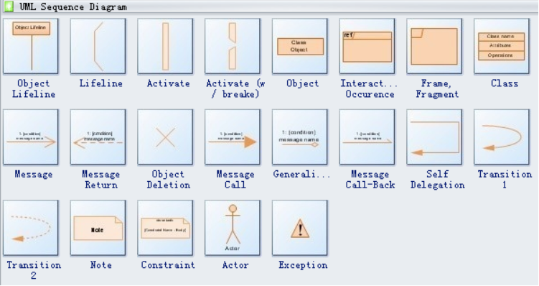

* **Sequence Diagram for Online Job Portal**



